Standard Operating Procedure (SOP) for Collecting Avian and Other Animal and Wildlife Species During Animal Mortality Events

Coordinate with the Utah State Wildlife Veterinarian for collection of carcass
- Annette Roug. Med Vet, MPVM, PhD :
Wildlife Veterinarian
Utah Division of Wildlife Resources
1594 West North Temple, Suite 2110
Salt Lake City, Utah 84116
801-589-3448 cell
aroug@utah.gov
- If you cannot contact Dr. Roug, contact Chris Cline, U.S. Fish & Wildlife Service
Christine Cline, M.S.- Environmental Toxicology, Natural Resource Restoration
U.S. Fish and Wildlife Service- Utah Ecological Services Field Office
2369 W. Orton Circle, Suite 50
West Valley City, Utah 84119
ph) 801.975.3330 x 145 fax) 801.975.3331 email) chris_cline@fws.gov
- Describe species, location, environmental conditions (e.g., proximity to, or suspected connection with blue-green algae—AKA cyanobacteria— bloom) and carcass condition.
- Only “freshly dead” carcasses in very good condition can be submitted for pathology. Decomposed or scavenged carcasses are of limited diagnostic value.
- Get approval for collection, make arrangements for delivery to shipper (Dr. Roug or Ms. Cline) or for direct shipment to the National Wildlife Health Laboratory (NWHC).
- Samples can only be collected on Monday-Thursday, so they can be received by the NWHC on a work day and in time to accept the sample. If a sample is collected on Thursday it must be delivered to the shipping point (Dr. Roug or Ms. Cline) by 12:00 Noon.
- A water sample should be collected with the carcass (see Item # 4 below) and delivered to Dr. Roug or Ms. Cline with the carcass. Dr. Roug or Ms. Cline will notify and coordinate with the Utah Division of Water Quality and/or the analytical laboratory regarding the receipt and analysis of the water sample.

Health and Safety
MOST IMPORTANT: NO SAMPLE IS WORTH YOUR HEALTH OR SAFETY!!!
- Wear appropriate and adequate personal protective equipment (PPE)
- Minimum protective clothing includes long pants, long-sleeved shirt, and closed-toe shoes
- Minimum PPE includes gloves (latex or nitrile if you have latex allergies), safety glasses and a particle mask
    - Algal toxins as well as botulism spores can be transferred by dermal-oral contact, and also by inhalation (e.g., spraying water or badly decomposed carcasses)
- If picking up a large number of animals or in wet conditions (e.g., on a boat), Tyvek coveralls may be called for.
- Under windy conditions or in other situations (e.g. traveling on a boat where a spray may be kicked up*), a higher degree of respiratory protection may be called for (e.g., half-face respirator with particulate/vapor (HEPA) cartridge). You must evaluate the situation before going in to determine what is adequate respiratory protection.
(* If traveling on a boat in an area with a cyanotoxin bloom, speeds should be decreased to the point that water droplets are not kicked up and sprayed onto people in the boat, such as from the bow of the boat)
- A Sampling Equipment Checklist is provided in Attachment 1

Collecting Samples for Pathological Exam
- The purpose of a pathology evaluation is to determine the animal’s cause of death.
- “Freshly dead” specimens are required (ideally 8 hours or less post-mortem).
  - Delicate organ tissues (lung, liver, kidney) break down rapidly in heat.
- Specimens should be preserved on wet ice, NOT FROZEN. Freezing destroys the cell structure in tissues and makes it difficult to see tissue damage that may have been caused by the agent of the mortality event.
- Place specimen in a plastic bag—
  - Zip lock quart or gallon sized for smaller birds and wildlife
  - Trash compactor bag (heavier plastic than a garbage bag) for larger birds & wildlife
- Place a label (use waterproof, “Rite in the Rain” paper if available) inside the bag with the specimen containing collection information. Minimum collection information includes:
  - Sample number or other unique identifier
  - Carcass species (common name or scientific name)
  - Date, time, collection location (include GPS lat/long coordinates if available)
  - Collector’s name
- Fill out USGS Wildlife Mortality Reporting Form (Attachment 2). Fill out form as completely as you can.
- Transport sample to shipping location (Dr. Roug or Ms. Cline) in a cooler filled with wet ice and/or “blue ice” type frozen coolant. NO DRY ICE (CO₂ ice).
- Samples should be transferred to the shipping point on the same day they are collected or early the next morning.

Collect Water Sample
- A co-located water sample should be collected at the same time and place as animal carcasses are collected. This will aid in the interpretation of pathology findings, as well as the interpretation of cyanotoxins in animal tissues if they are analyzed.
- 500 milliliters (approx. 16 oz) is required.
- Sample should be collected from water adjacent or nearby to the sample
- If scum is present, two samples should be collected: one (1) 16 oz. bottle that is mostly scum, and one (1) 16 oz. bottle that is mostly the water underlying the scum (if possible). If the area you are collecting from is very shallow, collect a single sample of whatever is there (scum and water).
- Fill out the Utah Division of Water Quality Water Sampling Field Data Sheet (Attachment X)
- Wash off the sample bottle and place in a ziplock bag before placing in a cooler filled with wet ice. The water sample can be placed in the same cooler as the carcass.

Samples should be transferred to the shipping point on the same day they ARE COLLECTED

Collect Incident information in the field
Fill out the Wildlife Mortality Reporting Form (Attachment 2) with the following information:
- Date carcass(es) found
- Your name and affiliation
- Date of disease onset (if known)
- Number, species, age, and sex of sick and dead animals.
- Whether animals were from the wild, wild animals from a captive facility, or domestic.
- Die-off location, including:
- Local geographic name (e.g., Moffett Lagoon, NE of Izembek Lagoon) and ownership if known (e.g., Izembek NWR)
- Waterbody name
- Street address or nearest city, town, or village
- State
- GPS coordinates
- Number, species, sex, age of carcasses and samples collected.
- Tissue, preservation method (formalin, frozen), and storage method (refrigerated, frozen) of collected samples.
- Carcass storage (refrigerated, frozen).
- Whether the animal was found dead, died in hand, or was euthanized (and euthanasia method).
- Whether rabies is suspected, and if so has there been any domestic animal or human contact.
- Symptoms displayed by sick animals (limp, neck arched back, blood coming from mouth, diarrhea, extremely thin, etc.).
- Other information that might be important for making a diagnosis (presence of cyanobacteria scum or affected water, wind, water conditions in area such as depth, smell, etc.

Collect Carcasses
- Use rubber, vinyl, or nitrile gloves when picking up sick or dead animals. If you do not have gloves, insert your hand into a plastic bag.
- More than one disease may be affecting the population simultaneously. If morbidly sick (i.e., dying) animals are observed, contact Dr. Roug to coordinate euthanasia.
- Collect specimens that are representative of all species affected and geographic areas.
- Collect the freshest dead specimens. Decomposed or scavenged carcasses are usually of limited diagnostic value.
- Fill out label and place on animal’s leg (or, if a fish, place in the inner bag with the fish). Place carcass in cooler containing blue ice blocks (preferred)

Transport Carcasses to Utah DWR or USFWS Utah Field Office
- Based on prior arrangement, transport carcass(es) as soon as possible to Utah DWR DVM (Dr. Annette Roug) or USFWS Environmental Contaminants staff (Chris Cline)
- Assist with completion of specimen submission form.
  - Scan and email or fax one form to the NWHC
  - Include a copy of the form inside the cooler with the carcass(es) (place form in a ziploc bag)

Ship Samples to Lab

CARCASSES- In most cases, dead birds can be submitted to the USGS National Wildlife Health Center (NWHC). Attachment 3 contains comprehensive information regarding reporting wildlife mortality events to the NWHC and shipping carcasses to their facility. Utah DWR (Dr. Annette Roug) or the Utah Field office of the U.S. Fish and Wildlife Service (Chris Cline) will ship carcasses, or provide instruction/oversight of carcass shipment
- Monday through Wednesday, ship specimens by overnight, next morning delivery service (e.g., FedEx®, UPS®). If specimens are fresh and need to be shipped on Thursday or Friday, please contact the lab to make arrangements. If shipping from a village, you may need to ship air freight to Anchorage, where the package can then be shipped to the lab.

WATER SAMPLES- In coordination with the Utah DEQ Division of Water Quality (UDWQ), water samples should be transferred to a UDWQ staff member or shipped to the analytical laboratory. The contact for Utah DWQ is:
Toby Hooker—801.536.4289; tobyhooker@utah.gov
- Follow instructions in Attachment 3 on how to properly package your carcasses or specimens.
- Print the “Exempt Animal Specimens” package label in Appendix F for your package.

ATTACHMENT 1: SAMPLING EQUIPMENT CHECKLIST

Personal Protective Equipment (PPE)
- Disposable Tyvek® or other fluid-resistant coveralls
- Rubber boots or boot covers
- Latex or nitrile gloves
- Safety goggles or glasses
- Respiratory protection- particle mask at a minimum. If there is a risk of aerosolized cyanotoxins, increased respiratory protection such as a half-face respirator with a particulate-VOC filter (e.g., HEPA filter) is advised
- Trash bags for contaminated waste
- Bucket and scrub brush
- Prepared disinfectant (Roccal-D Plus®, 10% bleach solution or other as appropriate)
- Designated “dirty”, “clean” and “decontamination” areas

Carcass Collection Equipment and Supplies
- Plastic Bags to place carcasses in (“Zip-lock” quart or gallon sized, or heavy-duty trash compactor bags for larger carcasses)
- Heavy duty trash compacter bags to double-bag carcasses with
- Wildlife Mortality Reporting Form (See Attachment 2)
- Cooler large enough to hold carcass plus ice* (see below)
- *Blue ice or water frozen in plastic bottles. If wet ice only is available, a) obtain block ice if possible; and b) place ice in a heavy plastic bag (e.g., trash compactor bag) and seal.
- Tag (Tyvek preferred) to label carcasses and bags. Get tags from Utah DWR Wildlife DVM. Or, write the following information on a piece of paper (waterproof preferred). You will need to fill out two tags (one for the carcass, and one for the outer bag):
  - Collector’s name
  - Collection Location (brief description)
  - Collection Location GPS coordinates
  - Collection Date
  - Species Name (common or scientific)
  - Species age (Adult, Juvenile) if known
  - Species gender (if known)
- Waterproof marker for labeling
- Zip ties, wire or string to fasten tags to carcasses and bags

Water Sample Collection Equipment and Supplies
- 500 ml (16 oz.) polyethylene bottle
- Utah Division of Water Quality Field Datasheet
- Water quality multi meter (pH. temperature, conductivity) (if available)

ATTACHMENT 2: WILDLIFE MORTALITY REPORTING FORM

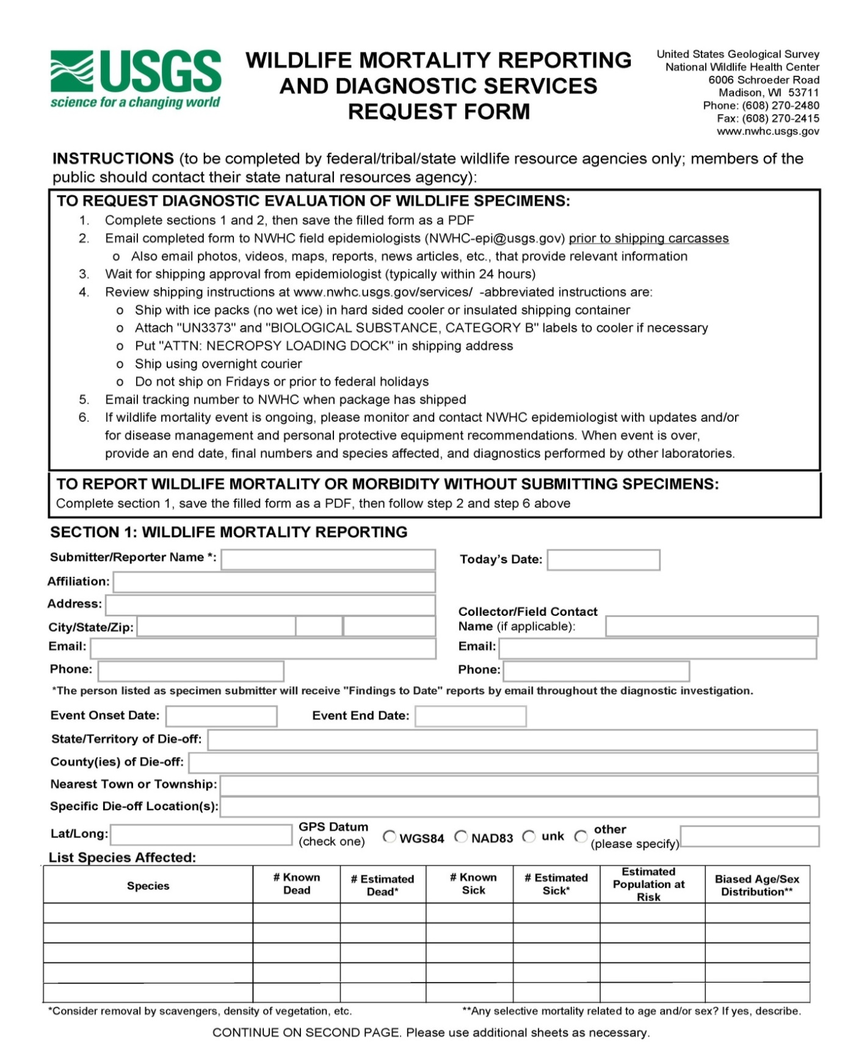

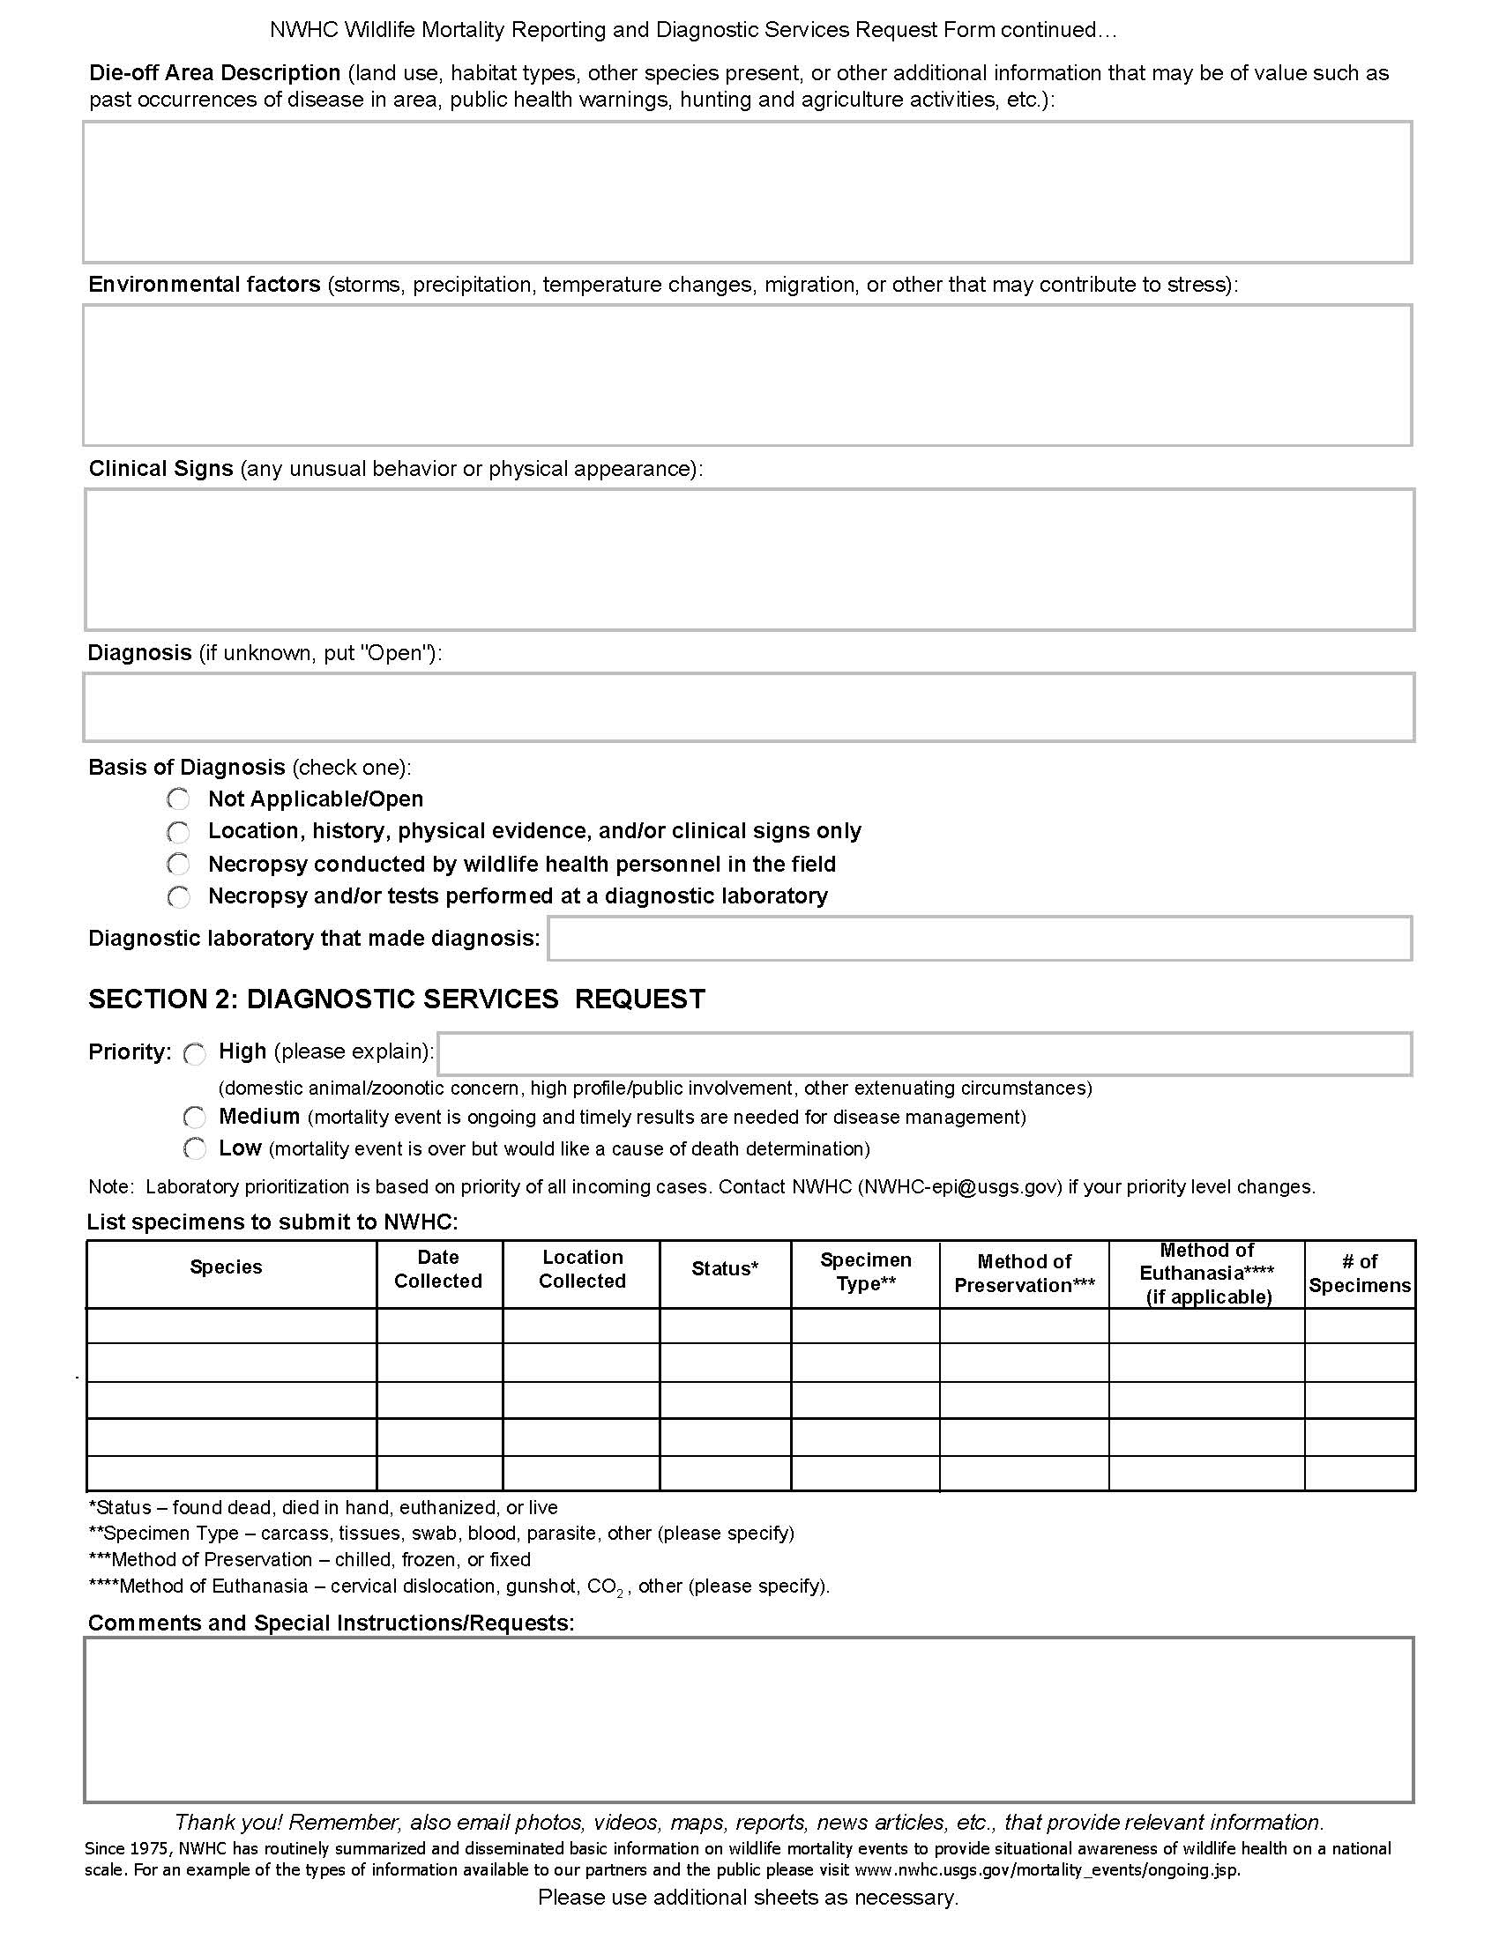

ATTACHMENT 3: Reporting Wildlife Mortality Events to USGS National Wildlife Health Center

If your agency is involved in a wildlife mortality event that is not reported, please contact the NWHC Field Epidemiology Team before sending any shipments: 608-270-2480, NWHC-epi@usgs.gov

Instructions for Collection and Shipment of Specimens
Download and fill out the Wildlife Mortality Reporting and Diagnostic Services Request Form. Save the filled form as a PDF and email it to NWHC-epi@usgs.gov. It is required for each shipment.

Follow the carcass collection and shipping instructions below (also available in PDF format, or video) and review the Diagnostic Case Submission Guidelines (PDF).

The following instructions should be used for collecting and shipping wildlife carcasses, carcass parts, and samples extracted from animals to the USGS National Wildlife Health Center (NWHC) in Madison, Wisconsin, to ensure adequate and well preserved specimens.
- Complete the “Wildlife Mortality Reporting and Diagnostic Services Request Form” and email/fax it to the NWHC epidemiology team to initiate discussion of the case you would like to submit and get shipping approval. Packages will not be opened if form does not arrive first.
- For most cases, NWHC prefers to receive fresh chilled specimens if they can be sent within 24-36 hours of collection or death, as freezing/thawing impedes isolation of some pathogens and causes tissue damage. As a general guideline: if you cannot call or ship within 24-36 hours, immediately freeze the animal(s) and keep frozen during shipment.
- Specimens should be shipped by 1-day (overnight) service, Monday through Wednesday, to guarantee arrival at NWHC before the weekend. If specimens are fresh and need to be shipped on Thursday or Friday, prior arrangements must be made. Email/fax shipment tracking number to NWHC.
- Collect animals under the assumption that an infectious disease or toxin is involved and other animals may be at risk. Protect yourself as some diseases and toxins are hazardous to humans. Use rubber, vinyl, or nitrile gloves when picking up sick or dead animals. If you do not have gloves, invert a plastic bag over your hand and use it as a glove to scoop specimen directly in to the bag.
- More than one disease may be affecting the population simultaneously. When possible, collect both sick and dead animals. Note behavior of sick animals before euthanizing. Record on carcass tags and “Wildlife Mortality Reporting and Diagnostic Services Request Form” which animals were euthanized.
- Collect specimens that are representative of all species and geographic areas involved.
- Suitable specimens should have intact body, eyes, and body cavity; have no maggots; and have no foul odors. Decomposed or scavenged carcasses are usually of limited diagnostic value. If you plan to collect animals in the field, take along a cooler containing ice to immediately chill carcasses.
- Contact NWHC for assistance when collecting specimens or samples from animals that are too large to ship. Other specimens might also require unique collection and shipping instructions (e.g., amphibians, bats, snakes); contact NWHC.

- Immediately attach a leg tag to each animal with the following information in pencil or waterproof ink:
  - Date collected
  - Species
  - Location (specific site, town, county, state)
  - Found dead or euthanized
  - Collector (name/address/phone)
  - Your reference #

ATTACHMENT 4: Packaging and Shipping Carcasses to the USGS National Wildlife Health Center

    - Bag Carcasses
- Place each animal in a separate plastic bag, close, and seal the bag. Cover zipper bag closure with strapping or duct tape after sealing zipper. Twist non-zipper bags closed, fold over on itself, and secure with package strapping or duct tape.
- Place 1st bag inside a 2nd bag, close and seal. More than one individually bagged animal can be placed in the 2nd bag. This prevents cross-contamination of individual specimens and leaking shipping containers.
- Tag the outside of 2nd bag and list number of animals and type, date collected, location, and name of collector. Reminder order: TAG, BAG, BAG, TAG.

    - Place Carcasses in Cooler and prepare for shipment
- Use a hard-sided cooler in good condition for shipment. Close the drain plug of cooler and tape over inside. Line cooler with a thick bag (1 mil thickness, 3rd layer of bags).
- Place absorbent material in the 3rd plastic bag to absorb any liquids that might leak during shipping. Example bags and absorbent materials are listed at the end of this guidance.
- Pack individually bagged animal(s) contained within the 2nd sealed bag into the 3rd bag with enough FROZEN BLUE ICE PACKS or similar coolant to keep carcasses cold. Use enough coolant to keep samples chilled if there is a delay in delivery.
  - Blue ice (unfrozen) can be obtained at hardware, sporting goods, or grocery stores.
  - Wet ice can be used if frozen in a sealed plastic container (i.e., soda or water bottle).
  - Do not ship using dry ice.
- Seal the 3rd bag with methods described for 1st bag.
- Place the completed “Wildlife Mortality Reporting and Diagnostic Services Request Form” (Attachment 2) and return shipping label (if you want the cooler returned) in a Ziploc bag and tape to the inside lid of the cooler. NWHC cannot pay for shipping.
- Tape the cooler shut around the lid and at each end using a continuous wrap around the cooler.

3. Label Cooler for Shipment
- Attach the shipping document (air bill) with the information below to the outside of each cooler in a resealable pouch. Also attach “to” and “from” addresses and phone numbers directly to the cooler.
  - Address:
Necropsy Loading Dock
National Wildlife Health Center
6006 Schroeder Road
Madison, WI 53711
608-270-2480
  - From Address/Emergency Contact:
Your Agency’s Address
Your Phone Number
  - Supplementary Labels:
Keep Cold
- Mark the cooler with the appropriate information: (Download PDF version for printable marking labels)
  - Carcasses of animals that died of unknown causes:
UN 3373 and BIOLOGICAL SUBSTANCE, CATEGORY B.
  - Blood and tissue samples from dead or sick animals:
UN 3373 and BIOLOGICAL SUBSTANCE, CATEGORY B.
  - Blood and tissue samples from apparently healthy animals (hunter-killed, live captured):
EXEMPT ANIMAL SPECIMENS.
- Note the shipment tracking number in case packages are delayed.
- These instructions cover shipping regulations for commercial carriers.

Example bags and absorbent materials available at large supermarkets (list not all inclusive):
- Inner and second layer bags:
- Hefty Big Bag – 22 gal
- Ziplock Freezer – 1 gal
- Hefty Freezer – 1 gal
- Ziplock Big Bag – 20 gal
- Hefty Jumbo – 2.5 gal
- Glad Freezer – 1 qt, 2 qt, 1 gal
- Third layer for cooler liner:
- Hefty Cinch Sack (1.1 mil) – 33 and 39 gal
- Glad Force Flex (1.05 mil) – 25 gal
- Hefty Lawn and Leaf (1.1 mil) – 33 and 39 gal
- Hefty Ultra Flex (1.3 mil) – 30 gal
- House brand large trash (1.1 mil) – 30 gal
- House Lawn - Leaf (1.2 mil) – 39 gal
- Absorbent material:
- Super absorbent packet or pads for water
- Cellulose wadding
- Paper towels
- Cotton batting or cotton balls
- Do not use packing peanuts or shredded paper.

See Following Page for Example (Printable) Shipping Label

UN3373
BIOLOGICAL SUBSTANCES, CATEGORY B

EXEMPT ANIMAL SPECIMENS

